EdTech Random_Forest

Key Insights:
- Overall dropout rate: 9.0% (26 of 290 students).
- login_frequency: dropout students average 95.69, compared with 248.34 among non-dropout students.
- forum_participation: dropout students average 118.08, compared with 342.83 among non-dropout students.
- task_submissions: dropout students average 11.81, compared with 21.09 among non-dropout students.
- connection_time: dropout students average 16.60, compared with 27.97 among non-dropout students.
- resource_views: dropout students average 478.46, compared with 1294.65 among non-dropout students.

Visualization :
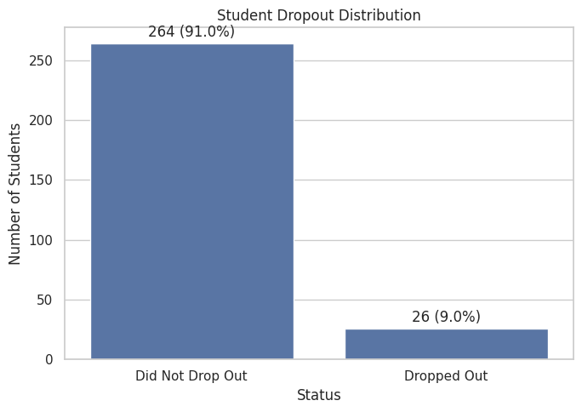

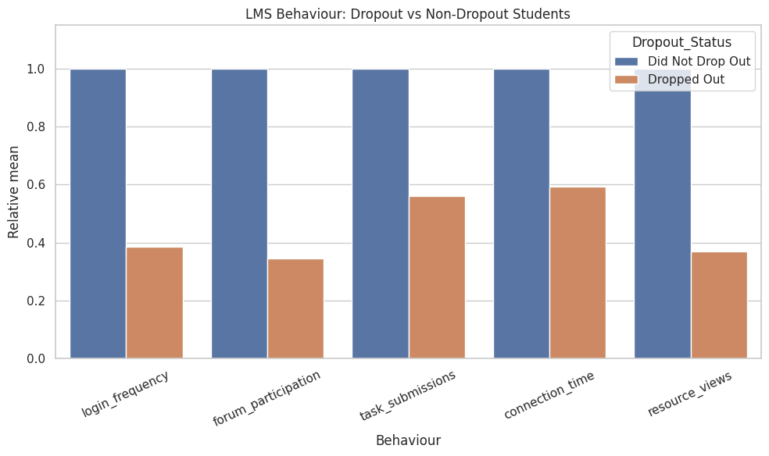
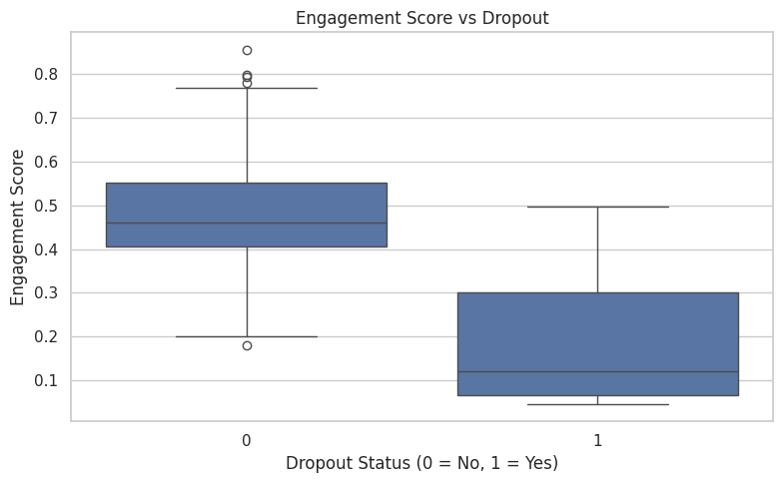
 | count | mean | median | std
Dropout_Status
0 | 264 | 0.475 | 0.46 | 0.109
1 | 26 | 0.176 | 0.12 | 0.132
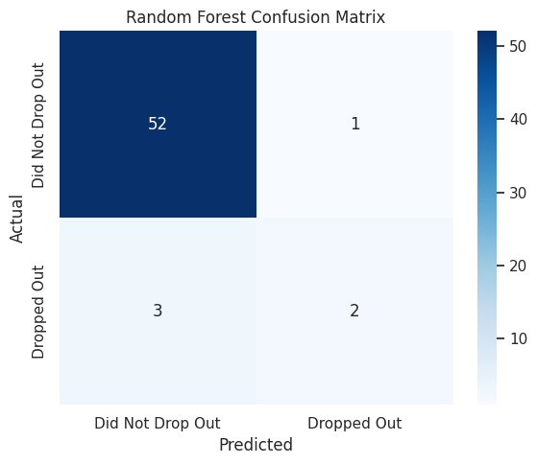
s

